Chapter 11, Problem 10.

In the op amp circuit in Fig. 11.42, find the total average power absorbed by the resistors.

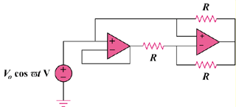

Figure 11.42
For Prob. 11.10.

